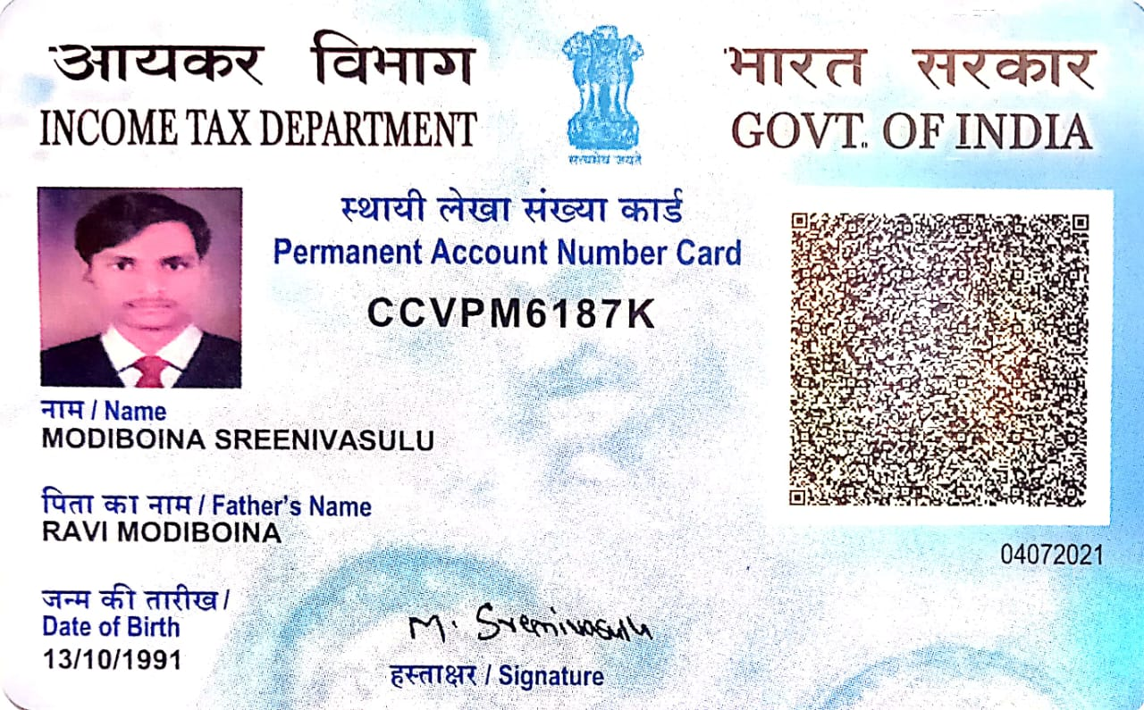

Candidate's Full Legal Name (as it appears on PAN)Vishal Nikam | Modiboina Sreenivasulu
Supplier Name (Registered Name) | People-prime Worlwide
Worked for CG previously? (IF yes share CG  Employee ID/GGID required | No
JOB Posting ID | CGEMJP00344961
Contact No (10 Digit No) | 9573038590
Email ID | srinivasulumulesoft@gmail.com
Job Location (Work Location) | Banaglore
Notice Period (Immediate/ Notice to Serve) | Immediate Joiner
Highest Education (Regular or Distance) | M. Tech
Employment Detail – Last 2 yrs Working period  (Payroll Company) | Interra Information Technologies
College & University Full Name - | Audisankara Engineering College
Mandatory Skills & Experience  (quick checklist – verify each skill, years of  experience) | Mulesoft -7 Years
“Secondary” Skills & Experience | Docker, Kubernetes – 7 years
Key Remarks (Supplier Comment) | Candidate Good at Communication Skill. He has relevant experience of 7 years.


Modiboina Sreenivasulu
Contact: +91-9573038590| Email:srinivasulumulesoft@gmail.com

Profile Overview
- Having 7 years of total industry experience in Analysis, Design, Development, Testing, Deployment, Admin and Documentation of Enterprise Application Integration (EAI) projects Using MuleSoft.
- 5.4 years of Strong MuleSoft development and team lead experience.
- Experience in Mulesoft over Anypoint Studio, Anypoint API Designer, Anypoint API Manager, Anypoint Connectors.
- Experience in the Mule Soft Anypoint API platform on designing and implementing Mule APIs.
- Expertise in using MuleSoftAnypoint Studio in creating various flows to integrate applications, Web services, APIs, and databases.
- Integrating the salesforce platform, oracle SQL Database, File Connectors, SOAP SERVICES..etc using Mule 4 in Anypoint studio.
- Good at handling the large volume data.
- Firm knowledge and hands-on implementing the MulesoftconnectorsandComponents like (Choice Router, Scatter gather, Batch processing, for each, Parallel foreachetc) in mule flow.
- Good hands-on and firm knowledge in performing the Munit test Cases to the mule flows (Mock When, Asset That, Assert equals, Set Event, Set Payload etc).
- Good Hands-on practice on Restful web services & SOAP web services.
- Have a Good understanding and knowledge of XML, JSON, CSV format types of payload.
- Proficient in Dataweave language with high experience in solving complex data transformations.
- Good hands-on in converting the TECHNICAL DESIGN DOCUMENT (TDD) file to .md formats.
- Good knowledge on RAML (Fragments, DataTypes, Traits, SecuritySchemaetc) at Anypoint platform.
- Good knowledge on Anypoint platform (Anypoint Design Center, AnypointExchange, Runtime Manager, API Manager etc).
- Have a good exposure on adding the Policy and Managing the mule API in Anypoint Platform.
- Highly motivated self-learner with good Problem-Solving Skills and committed to learning new technologies.
- Involved in requirement gathering of the project.
- Have firm and good experience in implementing synchronous and asynchronous flows.
- Have good knowledge of On-premises and cloud hub deployment model.
- Good Experience on implementing MuleSoft three-layered architecture (API Led) - Experience, Process and System Layers.
- Extensive hands-on experience in consuming as well as developing APIs for SOAP and REST based Web services.
- Experience in deployment of Mulesoft applications using Cloud Hub and knowledge using Mule ESB in integrating various third-party solutions.
- Good exposure for mule integration Flows using Anypoint Studio.
- Application integration experience using Mulesoft with connectors, transformations, Routing, Active MQ, JMS, Oracle EBS.
- Experienced in working with business analysts, development groups in analyzing business specifications and in working with other testers to resolve technical and end-user issues.
- Tightly integrated the Mule ESB with different application integrations.
- Designed and developed enterprise services using REST based APIs.
- Proactive in investigating and researching solutions for project related technical issues in coordination with Team members.

Work Experience

- Working as Member of Technical Staff at Interra Information Technologies (Mar-2025 to Dec-2025).
- Worked as Lead-Developer at IbridgeSofttech (Client: Eviden) (Dec-2024 to Jan-2025).
- Worked as Lead-Developer at NityoInfotech (Client: Infosys) (June-2023 to May-2024).
- Worked as Specialist - Software Engineering at LTIMindtree (July-2021 to May-2023).
- Worked as Software Engineer at C1 Technologies Limited (May-2018 to June-2021).

Education Details

- M.Tech (CSE),Audisankara Engineering College, Gudur, JNTUA, 2015 with 82%

Professional Certifications

- Achieved Mulesoft Certified Developer (MCD) Level - 1

Professional Skills

- Anypoint Platform: ESB, Anypoint API Designer, MMC, Cloud Hub, Runtime Manager, Anypoint Studio, RAML

- Web: HTTP, REST, XML, JSON
- Connectors: HTTP, Salesforce, Database, Workday, File, FTP/SFTP, AMQP, Microsoft Service Bus
- Message Transformation: JSON, XML, Data Weave, Java Collections, Data Mapper
- CI / CD: Maven, Jenkins, GitHub
- Operating Systems: Window 7/8/10, Linux
- Other Tools: Postman, JMeter.

Career Review
Mar 2025 – Dec-2025 with Interra Information Technologies as Lead Developer

Key Responsibilities:

  - Project : Mazda

  - Customer : MNAO

- Designed and developed scalable APIs using MuleSoft Anypoint Platform to integrate Mazda’s Salesforce CRM with SAP backend systems.
- Implemented System, Process, and Experience APIs following the API-led connectivity approach.
- Built CI/CD pipelines using GitHub Actions and deployed APIs to CloudHub.
- Improved data synchronization between dealerships and central inventory system, reducing latency by 40%.
- Worked closely with cross-functional teams across manufacturing, sales, and IT security to ensure smooth integration of over 10 enterprise systems.
- Designed and implemented complex data transformations using DataWeave 2.0 to convert data between JSON, XML, CSV, and Java objects.
- Performed advanced data mapping and enrichment using DataWeave functions and expressions to meet business logic requirements.
- Developed reusable DataWeave scripts to standardize transformations across multiple APIs and integrations.
- Optimized DataWeave logic to improve performance when handling large data sets and batch processing.
- Utilized DataWeave for data filtering, conditional logic, string manipulations, and date/time formatting within Mule flows.
- Transformed database query results into structured JSON responses using DataWeave for API responses.
- Handled nested and hierarchical data structures in DataWeave for seamless integration between systems like Salesforce, Oracle DB, and REST APIs.
- Applied error handling and default value strategies in DataWeave to manage unexpected or null input values.
- Implemented flattening and grouping operations in DataWeave for use in batch jobs and reports.
- Maintained and version-controlled transformation logic in separate .dwl files to promote reusability and clean architecture.
- Used DataWeave modules (dw::core, dw::util, etc.) to extend functionality and improve code maintainability.
- Participated in code reviews to validate the efficiency, accuracy, and scalability of DataWeave transformations.

Technology Used:MuleSoftanypoint Mule 4.x. Anypoint Studio 7.x/8.x Azure Platform, Application Gateway Service.
Dec 2024 – Jan 2025 with IbridgeTechsoft (Client: Eviden) as Lead Developer

Key Responsibilities:

  - Project : HCA

  - Customer : Syntel Inc

- Experience in Anypoint API platform on designing and implementing Mule APIs
- Developed Mule flows to integrate data from various applications like OFSC, IBM Maximo , some transformation mapping using MuleSoft also done at the integration layer and deployed the APIs to Live environment (Cloud Hub) using GitHub through CI/CD pipeline.
- Created new Mule integration flows for new applications using the design center.
- Extensively used Mule Components that include Data weave, Choice, HTTP Request, Scatter gather.
- Implemented Exception Handling and involved in coding, debugging, unit testing.
- Worked on ServiceNow incidents and Jira tickets for minor enhancements (Change Request).
- Implemented Health Check endpoint to find whether API’s are in active or inactive state.
- Followed the guidelines of Agile Methodologies and Followed SDLC approach for project management.
- Collaborated with business analysts to translate transformation requirements into efficient DataWeave logic within MuleSoft flows.
- Used multi-module DataWeave functions to structure transformation layers and improve testability across APIs.
- Created custom DataWeave functions and lambdas to handle reusable logic across multiple integration flows.
- Implemented conditional routing and branching logic directly within DataWeave to reduce flow complexity.
- Designed transformations for multi-part payloads and multipart/form-data using advanced DataWeave techniques.
- Implemented dynamic field mapping using DataWeave based on runtime metadata and payload structure.
- Worked on streaming large payloads with DataWeave to avoid memory issues and ensure performance in real-time data transfers.
- Integrated external APIs by transforming OAuth token responses and paginated data using DataWeave scripting.
- Developed audit log structures within DataWeave to log transformed payloads for monitoring and debugging.
- Used pattern matching and type coercion in DataWeave to handle inconsistent input from legacy systems.
- Generated custom error messages from failed transformations using try-catch blocks inside DataWeave expressions.
- Implemented property-driven transformations by externalizing field-level mapping logic from DataWeave to property files.
Technology Used:MuleSoftanypoint Mule 4.x. Anypoint Studio 7.x/8.x Azure Platform, Application Gateway Service.
Jun 2023 - May 2024 with NityoInfotech (Client: Infosys) as Lead Developer

Key Responsibilities:

  - Project : Conagra Brands Foods

  - Customer : Conagra Brands

- Worked with many of the components in Mulesoft like Transform Message, Connectors, and web service components and scopes.
- • Implemented and handling messaging exception in flows, creating, and using global exception handlers and global default exception strategy.
- Created Mulesoft flows using Mule Studio, performed payload transformation & used middleware frameworks for routing the messages to appropriate systems.
- Developed RESTful web services in Mule 4.
- Strong knowledge and hands on experience in documenting and designing REST API's using RAML.
- Experience in MuleSoftAnypoint studio on designing and implementing Mule APIs.
- Experience in integrating of different systems that includes Data Base, Java Migration.
- Developed RESTFUL/SOAP web services in Mulesoft.
- Experience in MuleSoftAnypoint API platform on designing and implementing Mule APIs.
- Experience in Deploying/Managing Mule flows to Composer and Jenkins.

Technology Used:MuleSoftanypoint Mule 4.x. Anypoint Studio 7.x/8.x Azure Platform, Application Gateway Service.
Nov 2022 - May 2023 with LTIMindtree – Hyderabad as Specialist-Software Engineer June 2021 - Oct 2022 with Mindtree as Module Lead

Key Responsibilities:

  - Project : BRITISH SUGAR INFORMATION MANAGEMENT IMP

  - Customer : BRITISH SUGAR PLC

  - Duration : June-2021 to Auguest-2022
- Migrated apps from mule 3.x to mule 4.x.
- Created MuleSoftanypoint Runtime fabric (RTF) using self-managed AKS cluster in Runtime Manager.
- Installed and activated rtfctl in AKS using activation code.
- Used rtfctl commands for validating activation code and installing rtfctl in AKS
- Used kubectl commands for getting the namespaces, pods and the logs of the mule app for Dev, QA and UAT environments.
- Applied mule license keys for accessing the environments.
- Exported mule deployable jar file to RTF.
- Developed mule flows and implementing the solution
- Involved in fixing the defects raised by the Dev, QA, UAT and Production.
- Developed complex data mappings and transformations using DataWeave 2.0 to convert between JSON, XML, and CSV formats.
- Created modular and reusable DataWeave scripts to handle dynamic field mappings and reduce code duplication across flows.
- Implemented error handling and default value logic in DataWeave to ensure smooth data processing from unreliable sources.

Technology Used:MuleSoftAnypoint Platform, Mule 3.x/4.x. Anypoint Studio 7.x/8.x, Runtime Fabric (RTF), Kubernetes Services, Azure Platform, Application Gateway Service.

  - Project : BRITISH SUGAR INFORMATION MANAGEMENT IMP

  - Customer : BRITISH SUGAR PLC

  - Duration : Sep-2022 to Feb-2023

- Worked with many of the components in Mulesoft like Transform Message, Connectors, and web service components and scopes.
- Developed and consumed REST web service and exposed APIs with RAML.
- Followed some best practice while developing API’s.
- Developed synchronous and asynchronous flows and routing messages based on conditions.
- Experienced in using Batch Processing in mule for processing bulk Data.
- Implemented and handling messaging exception in flows, creating, and using global exception handlers and global default exception strategy.
- Configured connectors and various messaging systems like JMS.
- Worked with various components like transformer, Data Weave.
- Reviewed the code which was developed by team members.
- Extensively used Postman to test Restful web service.
- Developed applications which connect to the client database and retrieve all the records and process to database.
- Good knowledge and Hands on experience in Snowflake, Salesforce CDP and Oracle EBS.

Technology Used:MuleSoftAnypoint Platform, Mule 4.x. Anypoint Studio 7.x/8.x, Runtime Fabric (RTF), Kubernetes Services, Azure Platform, Application Gateway Service.

  - Project : RnSS Core

  - Customer : Aaspire Pty Ltd

  - Duration : Mar-2023 to May-2023

- Develop REST APIs using MuleSoftAnypoint API Platform.
- Participate in requirements gathering sessions with application developers and functional users. Involve in API design sessions to decide various resources within each API, message schemas, message formats and authentication.
- Develop RAML documents using Anypoint API Platform. Provide mocking services to application developers.
- Implement the APIs using API-Kit Router in Anypoint Studio. Use Database and HTTP connectors to implement API Methods to read and write data to British sugar Information System.
- Develop API Portals to document the APIs.
- Unit test the APIs. Support user testing.
- Use CI / CD tools like Jenkins, Maven and GitHub during the development and deployment.
- Utilized DataWeave functions and lambdas to simplify complex conditional logic and improve code readability in transformation scripts.
- Designed streaming-based transformations in DataWeave to efficiently process large datasets without high memory consumption.
- Applied custom filtering and grouping logic in DataWeave to restructure payloads for downstream systems and reporting APIs.

Technology Used:MuleSoftAnypoint Platform, Mule 4.x. Anypoint Studio 7.x/8.x, CloudHub
May 2018 – June 2021 with C1 Technologies Limited– as Software Engineer

Key Responsibilities:

  - Client : Warner Brother’s

  - Duration : Oct-2019 to June-2021

- Development of mule flow configuration files.
- Developed and managed external properties file.
- Developed API Kit using RAML files for purchase Orders, Payments
- Actual resources with POST operations.
- Document work, attend client meetings and assist providing solutions to the respective issues
- Involved in all test connection.
- Deployed and managed APIs in CloudHub using Jenkins.
- Involved in applying security scheme to APIs.
- Involved in applying Test Driven Approach using Munit.
- Work with Mule AnyPoint Connectors: FTP, Database, Web services and JMS.etc.

Technology Used:MuleSoftAnypoint Platform, Mule 3.x/4.x. Anypoint Studio 6.x/7.x, CloudHub.

  - Project : Money 360

  - Duration : May-2018 to Sep-2019

- Involved in all testing related documentation
- Involved in developing test reports using templates and developed bug report.
- Involved in functional study of the application.
- Preparation and maintains of test data.
- Involved in bug reporting defects.
- Worked on production and merged defects for every release.

Technology Used: SDLC, SQL, JAVA, DATABASE, UML, SQL SERVER, TEST DIRECTORY, HTML, XML, Visual Basic, Oracle.

PERSONAL DETAILS-----------------------------------------------------------------------------------------------------------
Linguistic Abilities: Telugu and English
Address: Nellore, Andhra Pradesh, India Pin-524003| Date of Birth: 13th Oct 1991

